NOAA/NESDIS Products on the Internet that Can Be Helpful for Global Rainfall/Flooding Analyses/Forecasts and CIRA/Colorado State University Experimental Orographic Rain Index (ORI)

Blended Total Precipitable Water (TPW):
Updated every hour, this global product merges TPW vapor from a number of remote sensing satellites. High moisture areas and especially concentrations of high moisture, sometimes called “Atmospheric Rivers” often lead to heavy rainfall/flooding.
Global Blended TPW product for 03 UTC 21 Jan 2013 for monitoring moisture that resulted in Australia’s Oswald and Mozambique’s Heavy Rainfall/Flooding
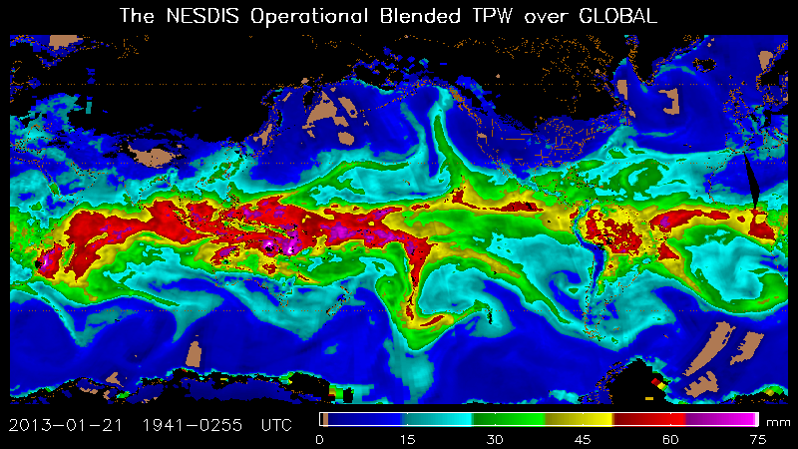
Main Internet Address: http://www.ospo.noaa.gov/Products/bTPW/index.html
For Australia: http://www.ospo.noaa.gov/Products/bTPW/TPW_Animation.html?product=AUSTRALIA_TPW
Paper: https://ams.confex.com/ams/pdfpapers/142967.pdf

Blended TPW Percent of Normal:
Also updated every hour this product displays in image form the TPW as a percentage of climatology. The normal value is based on a weekly climatology of total precipitable water that comes from NASA's 1988-1999 Water Vapor Project (NVAP). The TPW anomaly helps forecasters answer the question, "How unusually high or low is the total atmospheric moisture in a particular spot on the globe?”. Very high percentage values (>125% for tropics; > 150% for mid/high latitudes) can indicate a strong potential for heavy rainfall that can lead to flooding.
Global Blended TPW Percent of Normal product for 03 UTC 21 Jan 2013 for the monitoring of Australia’s Oswald and Mozambique’s Heavy Rainfall/Flooding
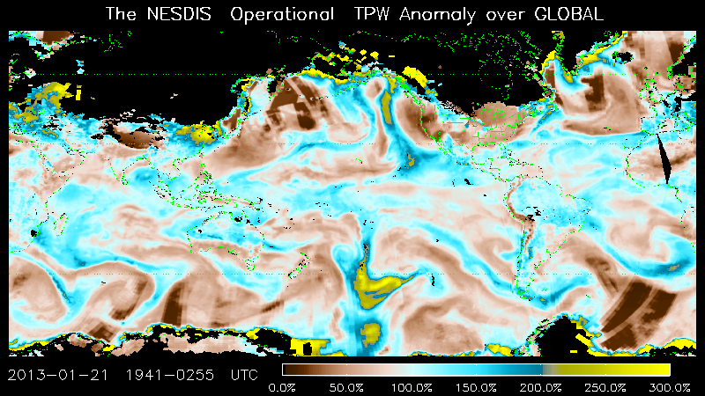
Main Internet Address: http://www.ospo.noaa.gov/Products/bTPW/index.html
For Australia: http://www.ospo.noaa.gov/Products/bTPW/TPW_Animation.html?product=AUSTRALIA_PCT
Paper: https://ams.confex.com/ams/pdfpapers/142967.pdf

Blended Rain Rate (RR):
This product is produced hourly by blending together the latest rain rate retrievals from passive microwave instruments on Defense Meteorological Satellite Program’s (DMSP) Special Sensor Microwave Imager Sensor (SSMIS) F-16, 17 and 18 and Polar Orbiting Environmental Satellite (POES) NOAA-18, NOAA-19 and Metop-A (METOP-B will be added this spring and Sunomi National Polar-orbiting Partnership (NPP) will be added later in 2013). The blended RR eliminates the bias between those data sets and provides a unified, meteorologically significant rain rate field for satellite analysts and weather forecasters. The product is generated with the latest 12 hours’ worth of rain rate retrievals from the above satellites. The output is an image of 16-km resolution areal average instantaneous rain rates.
Global Blended Microwave Instantaneous RRs at 03 UTC 21 Jan 2013. Heavy rain is seen from Oswald’s along the northeast coast of Australia and along the Mozambique coast. 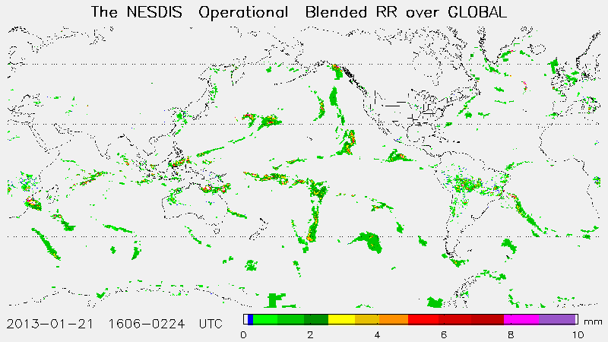
Main Internet Address: http://www.ospo.noaa.gov/Products/atmosphere/brr
For Australia: http://www.ospo.noaa.gov/Products/atmosphere/brr/brr_loops.html?product=AU&maptype=RR

QMORPH:
CPC QMORPH (Q MORPHing technique) produces global precipitation analyses at very high spatial and temporal resolution. This technique uses precipitation estimates that have been derived from low orbiter satellite microwave observations exclusively, and whose features are transported via spatial propagation information that is obtained entirely from geostationary satellite IR data. At present we incorporate precipitation estimates derived from the passive microwaves aboard the DMSP SSMI/S F 16, 17, 18, the NOAA-18, 19 and Metop-A &B MHS AMSU-B and TMI aboard NASA's TRMM spacecraft. Note that this technique is not a precipitation estimation algorithm but a means by which estimates from existing microwave rainfall algorithms can be combined. Therefore, this method is extremely flexible such that any precipitation estimates from any microwave satellite source can be incorporated. QMORPH estimates are similar to CMORPH estimates, except that the passive microwave precipitation features are propagated via IR data forward in time only with no morphing. QMORPH estimates are available within 3 hours of real time.
With regard to spatial resolution, although the preciptation estimates are available on a grid with a spacing of 8 km (at the equator), the resolution of the individual satellite-derived estimates is coarser than that - more on the order of 12 x 15 km or so. The finer "resolution" is obtained via interpolation.
In effect, IR data are used as a means to transport the microwave-derived precipitation features during periods when microwave data are not available at a location. Propagation vector matrices are produced by computing spatial lag correlations on successive images of geostationary satellite IR which are then used to propagate the microwave derived precipitation estimates. This process governs the movement of the precipitation features only. At a given location, the shape and intensity of the precipitation features in the intervening half hour periods between microwave scans are determined by performing a time-weighting interpolation between microwave-derived features that have been propagated forward in time from the previous microwave observation and those that have been propagated backward in time from the following microwave scan. We refer to this latter step as "morphing" of the features.
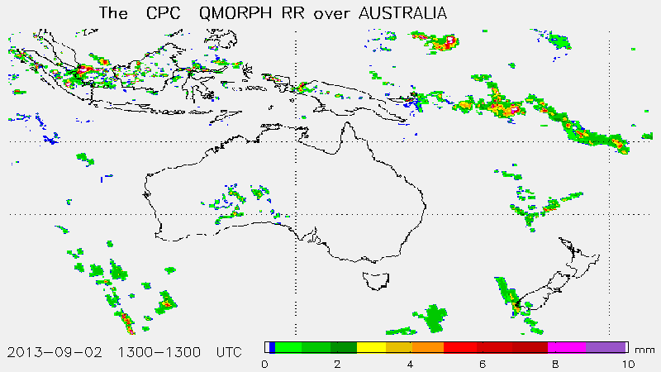
Global Hydro-Estimator (H-E):

The Hydro-Estimator (H-E) is a single-channel (11-μm) rain rate algorithm whose origins go all the way back to the semi-automated Interactive Flash Flood Analyzer (IFFA; Scofield 1987) which was originally developed in the late 1970s. Many of the IFFA's features were automated into the Auto-Estimator (A-E; Vicente et al. 1998) in the late 1990s, including rainfall rate as a function of IR window brightness temperature(calibrated against radar) and corrections for atmospheric moisture (the product of precipitable water (PW) in inches and decimal relative humidity (RH), orography (enhancements in upslope regions and reduction in downslope regions), and convective equilibrium level (enhances rain rates in regions where the convective equilibrium level height is low but strong updrafts can still occur). The H-E assigns rainfall only to pixels that are colder than the average of the surrounding cloudy pixels in order to eliminate cirrus clouds, and also uses separate PW and RH corrections to reduce cold-season overcorrection.

3-day Global H-E rainfall totals - 1200 UTC 18 Jan to 1200 UTC 21 Jan 2013 (Mozambique floods and beginning of heavy rainfall from Oswald for Northeast Australia)

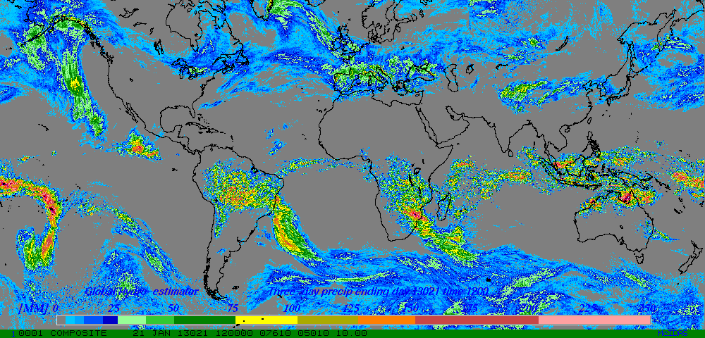
Internet Address: http://www.ospo.noaa.gov/Products/atmosphere/ghe

Global Ensemble Tropical Rainfall Potential (eTRaP):
eTRaP is a set of deterministic and probabilistic rainfall forecasts for global tropical cyclones that uses remote sensing microwave satellite rain rates (and in the future global geostationary satellite derived rain rates) and storrn-center track forecasts from the global Regional Specialized Meteorological Centers (RSMCs). eTRaPs are generated every 6 hours for global tropical cyclones that are named or numbered. The products use microwave rain rates from POES NOAA and METOP AMSU MHS and DMSP SSMIS satellite sensors to produce 6 and 24- hourly deterministic and probabilistic rainfall forecasts from these worldwide tropical disturbances.
Below is an example of an e-TRaP product suite of four 6-hourly and one 24-hour deterministic rainfall forecasts plus four 6-hourly and one 24-hour probabilistic forecast for four different thresholds for the next 24 hours.
Internet Address: http://www.ssd.noaa.gov/PS/TROP/etrap.html

Experimental Orographic Rain Index (ORI):
The ORI is designed to indicate to forecasters where there is short term (0-3 hours) potential for heavy orographic rainfall. The product has a resolution of 1 km. Three data sources used to create the product are: Blended TPW product which can indicate the strength and location of an atmospheric river impinging on land that has sloping topography; Numerical model 850 hPa winds (V), which are used to advect the water vapor to a forecast time (every three hours); USGS Global 30 Arc-Second Elevation Data terrain elevations (H) with a horizontal resolution of 1 km.
The addition of 850 hPa wind flow on the Blended TPW product and terrain gives the resultant experimental ORI for this 0300 UTC May 5, 2009 case for the West Coast of the U.S. The higher the value of ORI, the higher is the potential for heavy orographic rainfall.http://cat.cira.colostate.edu/ click on Orographic Rain Index (ORI) Current Product for West Coast of U.S. at: http://products.cira.colostate.edu/ORI/current.gif
Information at: http://rammb.cira.colostate.edu/research/goes-r/proving_ground/cira_product_list/orographic_rain_index.asp

